**Report**

**Part 1:**

The projection matrix is

[[ 0.45827554 -0.29474237 -0.01395746 0.0040258 ]

[-0.05085589 -0.0545847 -0.54105993 -0.05237592]

[-0.10900958 -0.17834548 0.04426782 0.5968205 ]]

The total residual is 8.542504

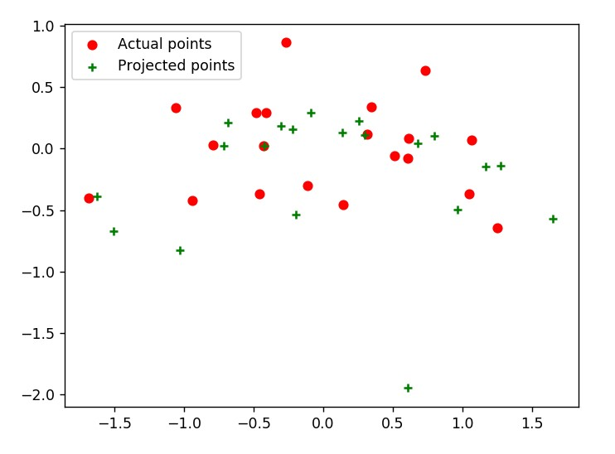

**Part 2:**

The estimated location of the camera is <1.4745, 2.3285, -0.4703>

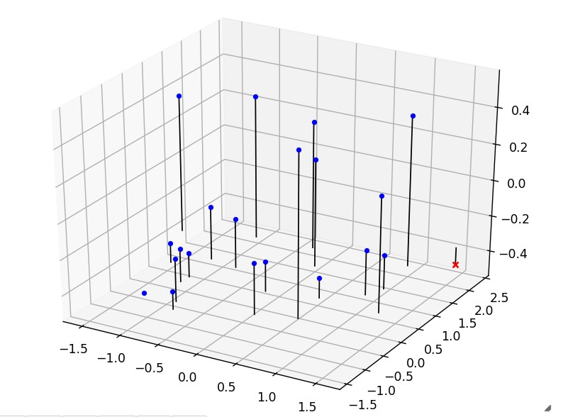

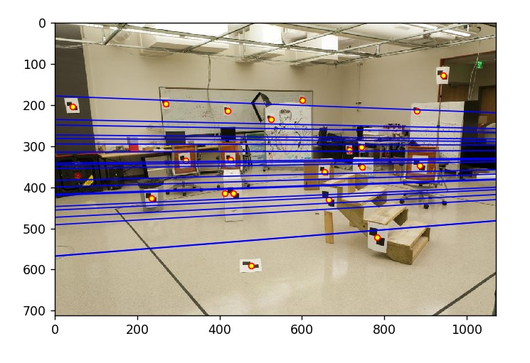

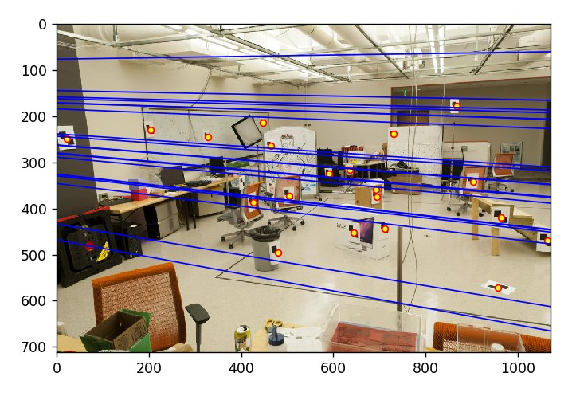

**Part 3:**

Threshold = 0.001

I have also put a limit on how many points are returned to be no more than 100.

